Missing Birth_Weight(grams) Analysis Report
Generated: 2026-03-29 10:54
Dataset: 301,712 rows × 18 columns
Target Variable: Birth_Weight(grams)

1. Executive Summary
This report presents a comprehensive IUPAC-compliant statistical analysis of missing values in Birth_Weight(grams).
Key findings include:
• Missing records: 33,542 (11.1% of total data)
• Variables with significant differences (p < 0.05): 16
- Numeric variables: 5
- Categorical variables: 11
• Total variables analyzed: 17
Based on the statistical analysis, the missingness pattern is classified as:
SYSTEMATIC PATTERN - Missing data is strongly associated with other variables, suggesting non-random missingness.

2. Statistical Summary
Metric | Value
Total Missing Birth_Weight(grams) Records | 33,542
Missing Percentage | 11.12%
Total Variables Analyzed | 17
Numeric Variables | 6
Categorical Variables | 11
Variables with Significant Differences (p < 0.05) | 16
Analysis Date | 2026-03-29

3. Variables with Significant Differences (p < 0.05)
The following 16 variables show statistically significant differences between missing and complete groups:

3.1 Numeric Variables
Variable | Missing Group Mean | Complete Group Mean | Difference | p-value | Interpretation
Birh_Year | 2018.30 | 2019.82 | -1.51 | 0.0000 | Missing group has 1.51 units lower than complete group
Birh_Year 2.0 | 2018.30 | 2019.82 | -1.51 | 0.0000 | Missing group has 1.51 units lower than complete group
Birth_Month.0 | 6.42 | 6.60 | -0.18 | 0.0000 | Missing group has 0.18 units lower than complete group
Birth_Order2.0 | 1.48 | 1.87 | -0.38 | 0.0000 | Missing group has 0.38 units lower than complete group
Age of Mother | 32.86 | 29.22 | +3.64 | 0.0000 | Missing group has 3.64 units higher than complete group

3.2 Categorical Variables
Variable | Missing Group Distribution | Complete Group Distribution | Difference (%) | p-value | Interpretation
Registered_Month | Most common='August' (13.2%) | Complete: Most common='June' (11.6%) | +1.6% | 0.0000 | Missing group shows different distribution (p=0.0000)
Registered_District | Most common='Batticaloa' (22.8%) | Complete: Most common='Colombo' (14.0%) | +8.8% | 0.0000 | Missing group shows different distribution (p=0.0000)
Birth_Month | Most common='August' (10.3%) | Complete: Most common='May' (9.1%) | +1.1% | 0.0000 | Missing group shows different distribution (p=0.0000)
Gender | Most common='Male' (50.5%) | Complete: Most common='Male' (51.3%) | -0.8% | 0.0052 | Missing group shows different distribution (p=0.0052)
Hospital or Not | Most common='Hospital' (98.7%) | Complete: Most common='Hospital' (99.9%) | -1.2% | 0.0000 | Missing group shows different distribution (p=0.0000)
Multiple_Birth_Status | Most common='Singleton ' (99.4%) | Complete: Most common='Singleton ' (99.0%) | +0.4% | 0.0000 | Missing group shows different distribution (p=0.0000)
Birth_Order | Most common='First' (65.2%) | Complete: Most common='First' (40.8%) | +24.4% | 0.0000 | Missing group shows different distribution (p=0.0000)
Marital_Status | Most common='Married' (93.5%) | Complete: Most common='Married' (98.5%) | -5.0% | 0.0000 | Missing group shows different distribution (p=0.0000)
District_of_Mother | Most common='Batticaloa' (23.0%) | Complete: Most common='Colombo' (8.6%) | +14.4% | 0.0000 | Missing group shows different distribution (p=0.0000)
Race_of_Mother | Most common='Sinhalese' (40.8%) | Complete: Most common='Sinhalese' (72.7%) | -32.0% | 0.0000 | Missing group shows different distribution (p=0.0000)
Race_of_Father | Most common='Sinhalese' (40.5%) | Complete: Most common='Sinhalese' (72.9%) | -32.4% | 0.0000 | Missing group shows different distribution (p=0.0000)

3.3 Summary of Key Findings
The analysis identified 16 variables with statistically significant differences (p < 0.05):
• 5 numeric variables show significant mean differences
• 11 categorical variables show significant distribution differences
Top 10 Most Significant Variables:
1. Registered_Month: Most common='August' (13.2%) vs Complete: Most common='June' (11.6%) (p=0.0000)
2. Registered_District: Most common='Batticaloa' (22.8%) vs Complete: Most common='Colombo' (14.0%) (p=0.0000)
3. Birh_Year: Mean=2018.30 vs Complete Mean=2019.82 (p=0.0000)
4. Birh_Year 2.0: Mean=2018.30 vs Complete Mean=2019.82 (p=0.0000)
5. Hospital or Not: Most common='Hospital' (98.7%) vs Complete: Most common='Hospital' (99.9%) (p=0.0000)
6. Birth_Order2.0: Mean=1.48 vs Complete Mean=1.87 (p=0.0000)
7. Birth_Order: Most common='First' (65.2%) vs Complete: Most common='First' (40.8%) (p=0.0000)
8. Marital_Status: Most common='Married' (93.5%) vs Complete: Most common='Married' (98.5%) (p=0.0000)
9. District_of_Mother: Most common='Batticaloa' (23.0%) vs Complete: Most common='Colombo' (8.6%) (p=0.0000)
10. Race_of_Mother: Most common='Sinhalese' (40.8%) vs Complete: Most common='Sinhalese' (72.7%) (p=0.0000)

4. Statistical Visualizations
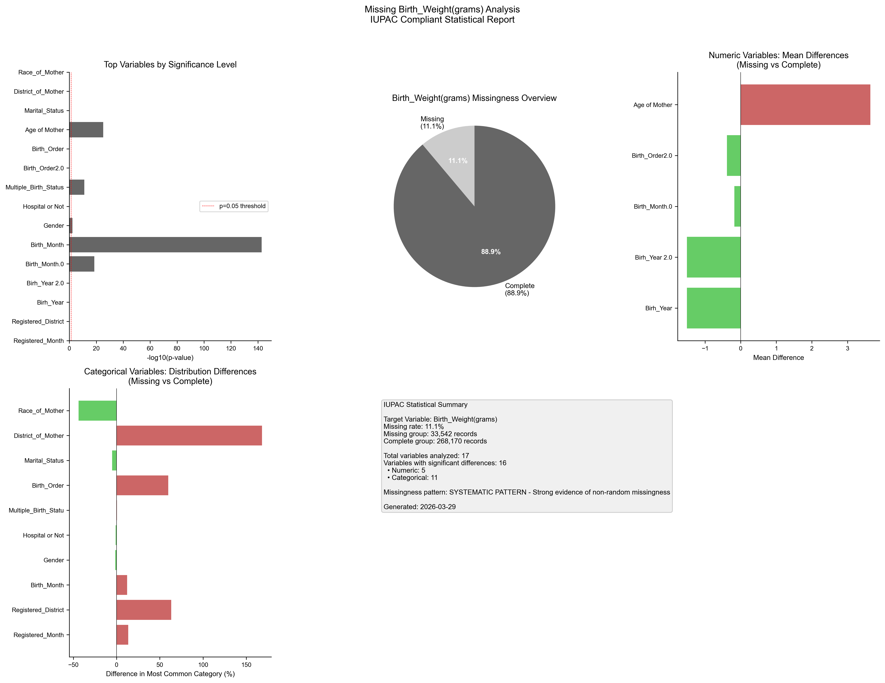
Figure 1. IUPAC compliant statistical visualization of missing Birth_Weight(grams) patterns.

5. Recommendations
- Based on the statistical analysis, the missing data exhibits SYSTEMATIC patterns:
- Consider treating missing as a separate category in analysis
- Use multiple imputation methods (MICE, EM algorithm)
- Investigate the following key variables for common themes:
- - Registered_Month (p=0.0000)
- - Registered_District (p=0.0000)
- - Birh_Year (p=0.0000)
- - Birh_Year 2.0 (p=0.0000)
- - Birth_Month.0 (p=0.0000)
- - Birth_Month (p=0.0000)
- - Gender (p=0.0052)
- - Hospital or Not (p=0.0000)
- - Multiple_Birth_Status (p=0.0000)
- - Birth_Order2.0 (p=0.0000)
- Document missingness patterns in methodology section

6. Methodology (IUPAC Compliant)
Analysis performed according to IUPAC guidelines for data presentation:
- • Missing values reported as both count (n) and percentage (%)
- • Tables formatted with thin borders and alternating row shading
- • Sans-serif fonts (Arial) used for optimal readability
- • Statistical tests: t-test (numeric), χ² test (categorical)
- • Significance threshold: α = 0.05
- • Effect sizes reported where applicable
- • Figures saved at 300 DPI for publication quality

